Mentorship Program - Smart Assignment Engine

**Category: Cloud Application Development**

**The Business Problem**

SMART aims for a driving force that will innovate the education system including education environment, method and evaluation. To bring innovation to the overall school education system, a comprehensive measure should be implemented based on improvement of the system and teachers’ capabilities, which require active support.

Smart Assignment is a web-based application designed to streamline the process of assignment management and enhance collaboration among students, teachers, and administrators. This project aims to leverage web development technologies to create an intelligent platform that automates assignment creation, submission, grading, and feedback, thereby improving the efficiency and effectiveness of the assignment process. Students can access the platform to view and submit assignments. The application allows for secure file uploads, ensuring the integrity and confidentiality of submitted work. The system provides notifications and reminders to students about upcoming assignment due dates and any updates or clarifications from teachers.

Smart Assignment aims to enhance the assignment management process, promote collaboration, and improve educational outcomes. By leveraging intelligent technologies and providing a user-friendly interface, the application streamlines administrative tasks, enhances student-teacher communication, and facilitates a more efficient and engaging learning experience.

**Business Requirements**

* Robustness
* Backward and Forward compatibility with LMS systems
* Good User Experience and Interface
* Automated Assessment System

**Literature Survey**

The growth of education is dynamically changing along with emerging technology. Learning management systems (LMS) takes an essential place regarding support its process. By many kinds of improvement aspect within technology, adaptive user interface (AUI) has a significant role to maintain students engagement in learning activities. However, it is very significant to analyze the development of AUI in education 4.0 to understand its significant challenge at this stage. This paper discusses AUI in learning system which has been proposed and implemented by other researchers. We apply a comparative perspective between technology and heutagogical aspect in evaluating their approaches. By delivering this perspective, the paper presents a short review of LMS adaptivity trends and development challenges in the field of learning services for education 4.0.

UI Design

AUI technologies which offer more automation regarding learning process affect more changes to users. In a perspective of AI technologies, the changes also make systems to learn based on some inputs recover in adaptability. However, automation to generate UI design also gives impact to UI consistency.

• Proper evaluation Evaluating an adaptive LMS with a multifunctional way of learning should cover more approaches. The evaluation leads to the success of adaptation implementation to achieve goals for better learning.

**Social Impact and Business Impact**

Social Impact: It will make the life of a student on campus much easier. Professors also no need to carry the big pile of notebooks submitted by students and the transparency of marks allotment also will be there.   
1.     Development and application of digital learning management systems.

2.     Strengthening teachers’ capabilities & trainings for implementing SMART Education

3.     Online classes and establishment of real-time online assessment system.

4. Application of modern assessment techniques aiming at evaluating student ideas and constructive feedback mechanism.

5. Greater Transparency in assessment.

Business Model/Impact:  It will also give a positive impression about the university around the time of admissions and can be made by digitizing the campus.

The adoption of technology in education has led to an unprecedented transformation from teacher-centric education towards student-centric education. It enhances the engagement between the teacher and students as close to the classroom type experience. Going forward, smart classrooms are making everything possible from teachers and parent meetings to staff/management meetings, providing the necessary interactivity.

**IMPLEMENTATION**

Redhat link - <https://cadtest-sridevi-taradi-dev.apps.sandbox-m4.g2pi.p1.openshiftapps.com/>

**Application Screenshots**

**Redhat Screenshots**

**Deployment link -** [**https://cadtest-sridevi-taradi-dev.apps.sandbox-m4.g2pi.p1.openshiftapps.com/**](https://cadtest-sridevi-taradi-dev.apps.sandbox-m4.g2pi.p1.openshiftapps.com/)

Docker Screenshots

Docker Images and Login

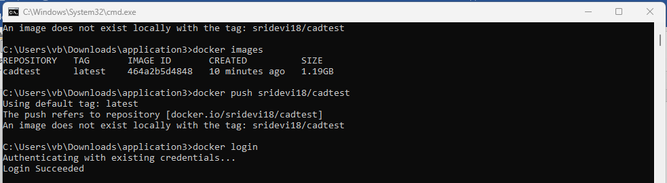

Docker Push

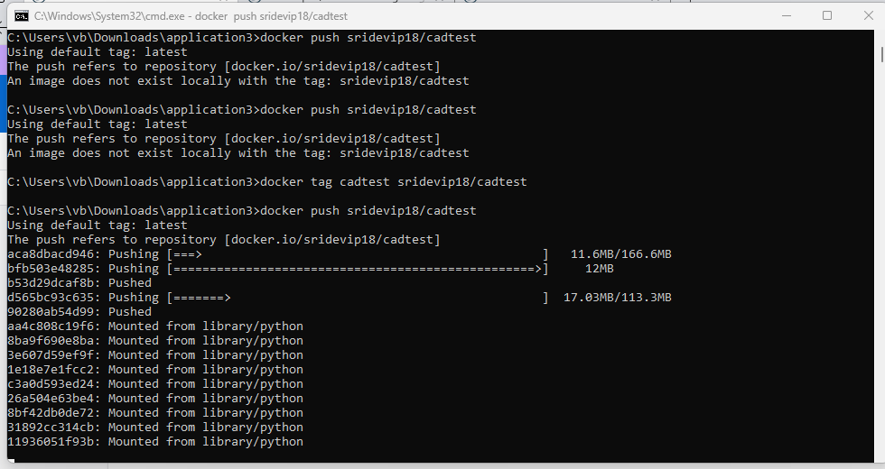

Docker Hub

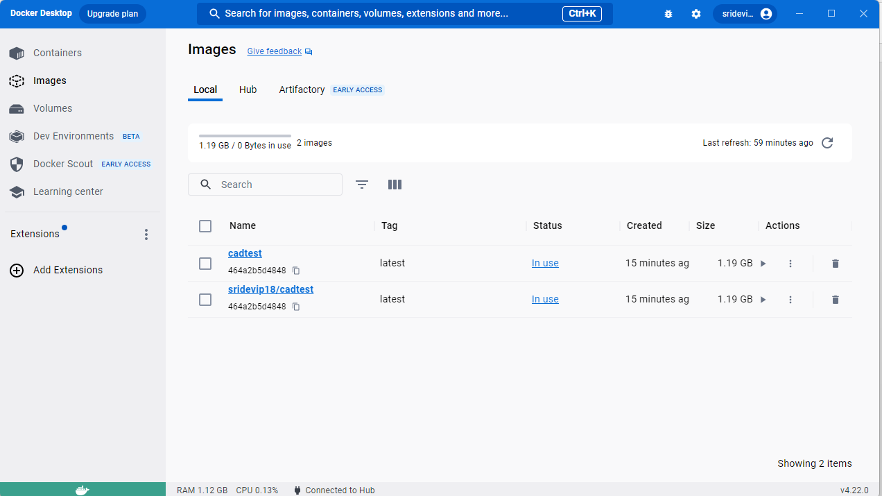

Docker run

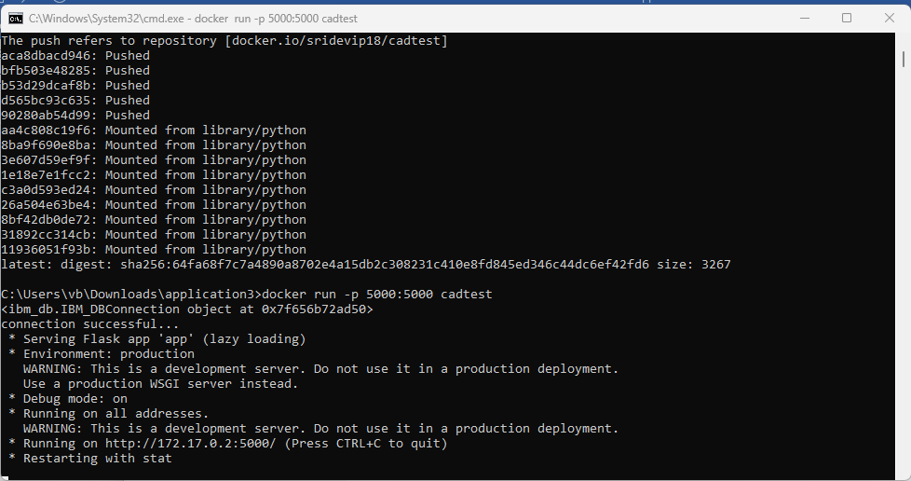

Docker running

Docker output

Docker pull

